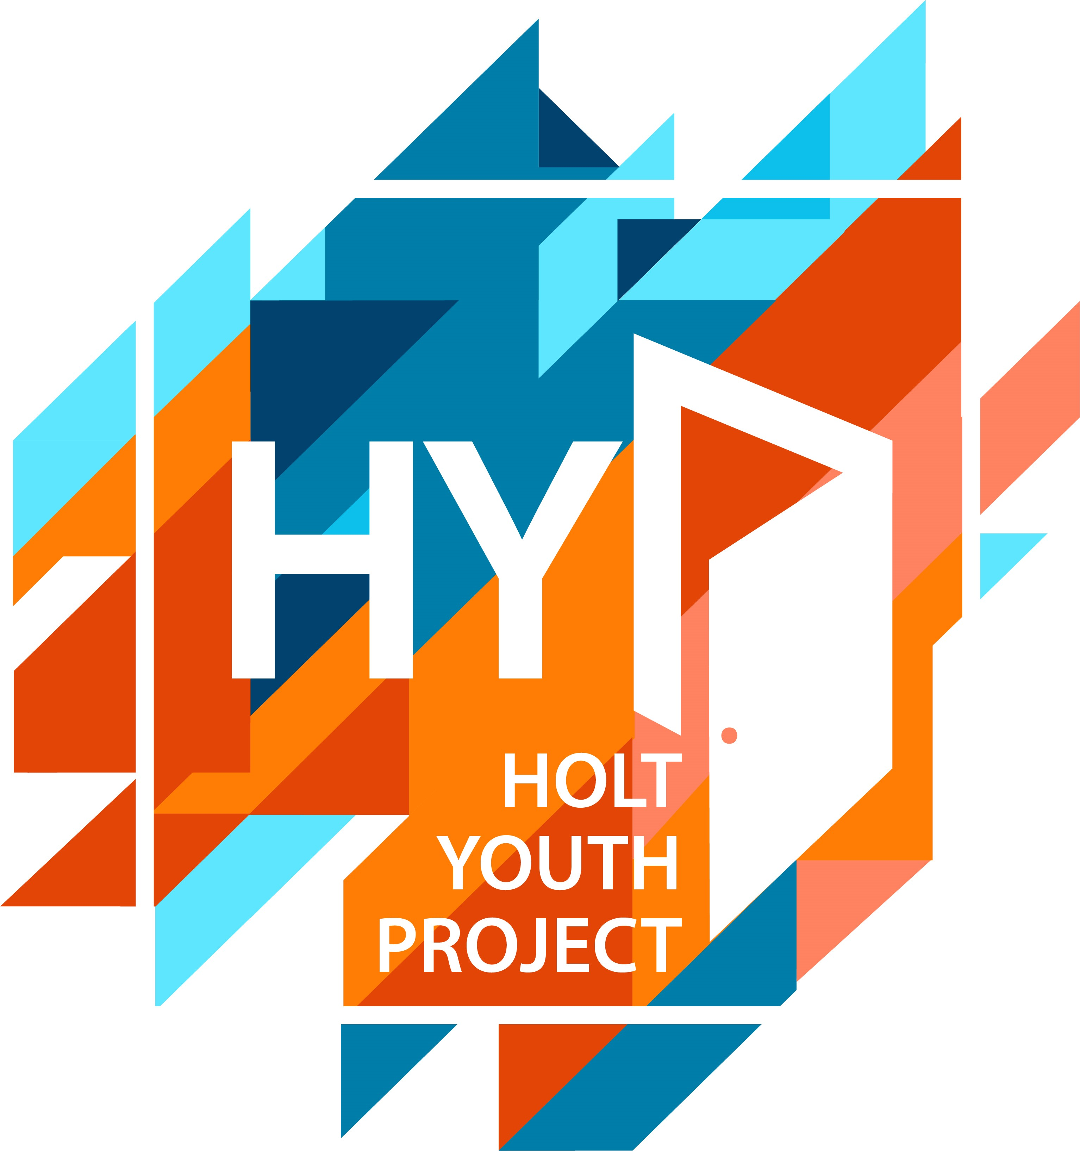

HOLT YOUTH PROJECT
Registered Charity No. 1128752
Old Station Way, Holt, Norfolk NR25 6DH
http://www.holtyouthproject.org.uk/Tel: 01263 710918

Membership Application

Junior Youth Senior Youth Young Carers Holiday Programme ACT

Surname: | First names: Male/Female
Date of birth: | School:
Address:  ………………………………………………………  ……………………………………………………..  ……………………………………………………..  Postcode: ……………………………………  Email: …………………………………………. | Emergency contact details: Parent/Guardian (delete one)  Name: ……………………………………………………………………  Home telephone: ………………………………………………….  2nd telephone number …………………………………………..  (for emergency use only)
Health details - Does your child suffer from…?
YES/NO Asthma or Bronchitis  YES/NO Sight or hearing difficulties  YES/NO Allergies to pollen, dust, stings or animals  YES/NO Allergies to any drugs or first aid items YES/NO Food allergies or intolerance, please detail ………………………………………………………… | YES/NO Heart condition  YES/NO Epilepsy  YES/NO Severe headaches  YES/NO Fits, fainting or blackouts  YES/NO Any other illness
If you have answered YES to any of the above health questions, or if there is anything else which we should be aware of please give full details below

…………………………………………………………………………………………………………………………………………………………………….

…………………………………………………………………………………………………………………………………………………………………….

…………………………………………………………………………………………………………………………………………………………………….

…………………………………………………………………………………………………………………………………………………………………….

*Parents and guardians are encouraged to talk to us if they have any queries or concerns

Activities
Please indicate if you, as parent or guardian, give your permission for the following:

YES/NO Travelling in the Holt Youth Project/Partners minibus/senior youth worker’s car
YES/NO The child/young person has your permission to use the gym
YES/NO The child/young person’s data can be held on Holt Youth Projects database for the duration of their membership

We would be grateful if you would complete this form to give us permission to take photos of your child and use these in our printed and online publicity.

- I give permission to take photographs and / or video of my child. YES/ NO

- I grant full rights to use the images resulting from the photography/video filming for fundraising, publicity or other purposes to help achieve the group’s aims. This might include (but is not limited to), the right to use them in Holt Youth Projects printed and online publicity, social media, press releases and funding applications. YES/NO

Signature: …………………………………. ……………. Print Name ………………………………………..

The Holt Youth Project Contract

Our membership contract has been created by our young people. Each member is required to sign this form saying that he or she will abide by the rules of the Youth Project. The Project and its immediate area,
is a safe environment and is smoke and alcohol free.

Signed: …………………………………………………Print Name………………………………………… Date……………………..
(Parent or guardian if under 18)

All of the above data will remain confidential and will be destroyed when membership comes to an end. We will not share your data with anyone without express permission.

GENERAL DATA PROTECTION PRIVACY NOTICE

The Holt Youth Project is committed to protecting the privacy and security of your personal information. This privacy notice describes how we collect and use personal information about you during and after your working relationship with us, in accordance with the General Data Protection Regulation (“GDPR”).

DATA PROTECTION PRINCIPLES
We will comply with data protection law. This says that personal information we hold about you must be:
- Used lawfully, fairly and in a transparent way.
- Collected only for valid purposes that we have clearly explained to you and not used in any way that is incompatible with those purposes.
- Relevant to the purposes we have told you about and limited only to those purposes.
- Accurate and kept up to date.
- Kept only as long as necessary for the purposes we have told you about.
- Kept securely.

